3. Water Jug Problem
Aim:
To obtain the required amount of water using two jugs of different capacities.
Procedure:
- Define the capacities of the two jugs.
- Fill, empty, or pour water between the jugs.
- Apply the valid operations.
- Repeat until the target amount is obtained.
- Display the sequence of steps.
Output:
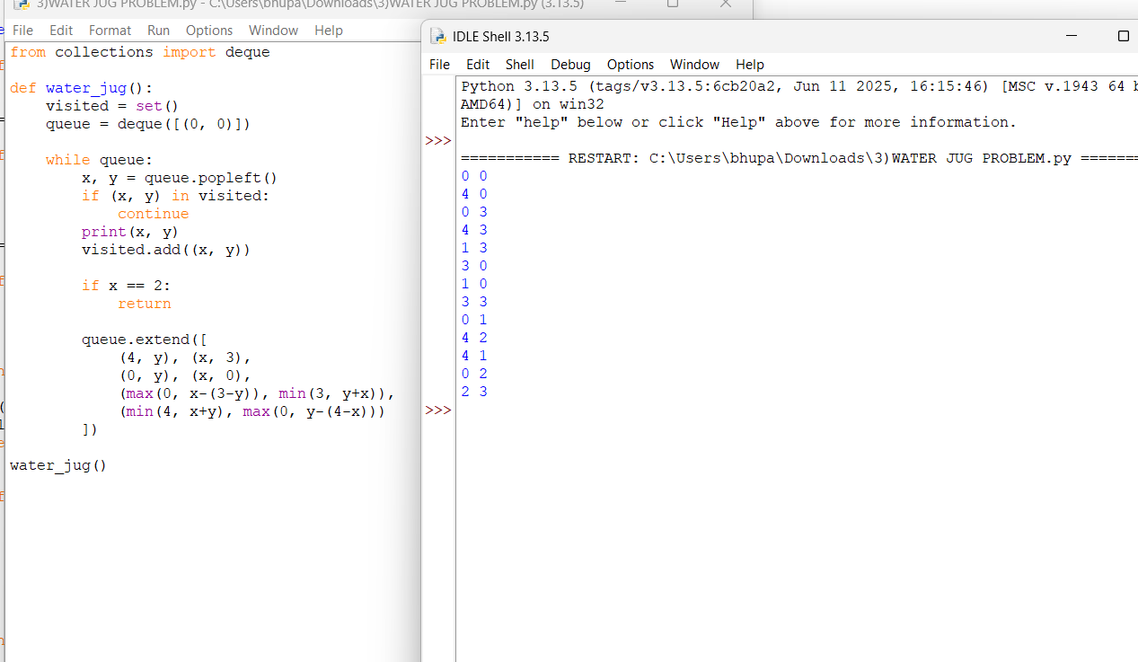Result:
The required quantity of water was obtained successfully.

